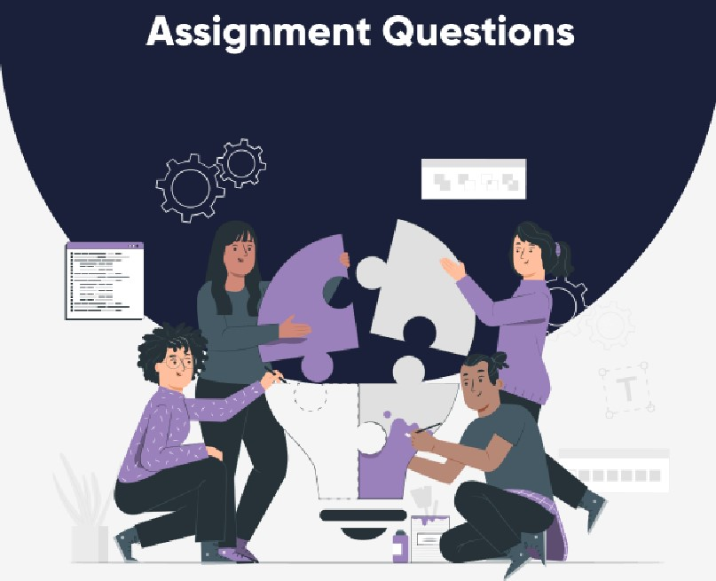PYTHON

* Who dove loped python Prog rammin Language?
* 2. Which type of programming does python support?

a. Is python case sensitive when i ing with idem Eifiers?

a. What is the correct extension of the python fiio? S. Is python coda compiiad or interpreted?

6. Name a few bleus of code used to define in python language?

i. State a character usedto give single—line commones inpythonP

g. Mention functions which can help us ea find the version of python that wo aro currently working on?

1. python supports the emotion of anonymous functions at runtime using a constr uet eaiiød
2. What does pip s tand for python?

n. Me ntion a low built—in functions in pyth on?

1. What is the maximum possible length of an identifier in Python?
2. What are the benefits of using Python?
3. How is memory managed in Python?

IS. How to install Python on Windows and set pa th variables?

16. Is indentation required in python?

cota science Masters